AI Assisted Coding (III Year) Assignment
Name: B. Rithwik
HT NO: 2303A52330
Batch: 35

Assignment Number: 12.1 / 24

Lab 12: Algorithms with AI Assistance – Sorting, Searching, and Optimizing Algorithms

Lab Objectives
- Use AI to assist in designing and implementing fundamental data structures in Python
- Learn prompt-based structure creation, optimization, and documentation
- Improve understanding of Lists, Stacks, Queues, Linked Lists, Graphs, and Hash Tables
- Enhance readability and performance with AI-generated suggestions

Task 1: Merge Sort Implementation

Code Explanation
Merge Sort is a divide and conquer algorithm that divides the list into smaller parts until each sublist contains only one element. Then it merges the sublists by comparing elements and arranging them in sorted order. This process continues until the complete list is sorted. The algorithm has a consistent time complexity of O(n log n) in all cases, which makes it efficient for large datasets. However, it requires extra memory during the merging process, so its space complexity is O(n). It is also a stable sorting algorithm.
AI Prompt Used
Write a Python function named merge_sort(arr) to implement the Merge Sort algorithm. Include proper docstrings explaining time and space complexity and provide test cases.

Task 2: Binary Search

Code Explanation
Binary Search works only on sorted data and reduces the search space by half in every step. It compares the target element with the middle element of the list and continues the search in the left or right half based on comparison. This makes the algorithm much faster than linear search for large datasets. The best case occurs when the element is found in the middle, which takes O(1) time, while the average and worst cases take O(log n). Since this implementation uses an iterative approach, the space complexity is O(1).
AI Prompt Used
Generate a Python function binary search(arr, target) that returns the index of the target element or -1 if not found. Include docstrings explaining best, average, and worst-case complexity.

Task 3: Inventory Management System
Recommended Algorithms
Operation | Algorithm | Justification
Search by Product ID | Hashing | Fast lookup
Search by Name | Hash Table | Efficient retrieval
Sort by Price | Merge Sort | Stable and efficient
Sort by Quantity | Merge Sort | Suitable for large data


Code Explanation
Large inventory systems require fast searching and sorting. Hashing is used to search products quickly using product IDs because it provides constant time complexity on average. Python dictionaries work efficiently for this purpose. Sorting products based on price or quantity helps in analysis and decision-making, and Merge Sort or Python’s built-in sorting ensures stability and efficiency. This approach improves performance even when the dataset grows large.
AI Prompt Used
Suggest efficient searching and sorting algorithms for an inventory system with thousands of products. Implement Python functions and justify the selection.

Task 4: Smart Hospital Patient Management System
Recommended Algorithms
Operation | Algorithm | Justification
Search by Patient ID | Hashing | Instant access
Search by Name | Hash Table | Efficient
Sort by Severity | Priority sorting | Critical cases first
Sort by Bill | Merge Sort | Efficient

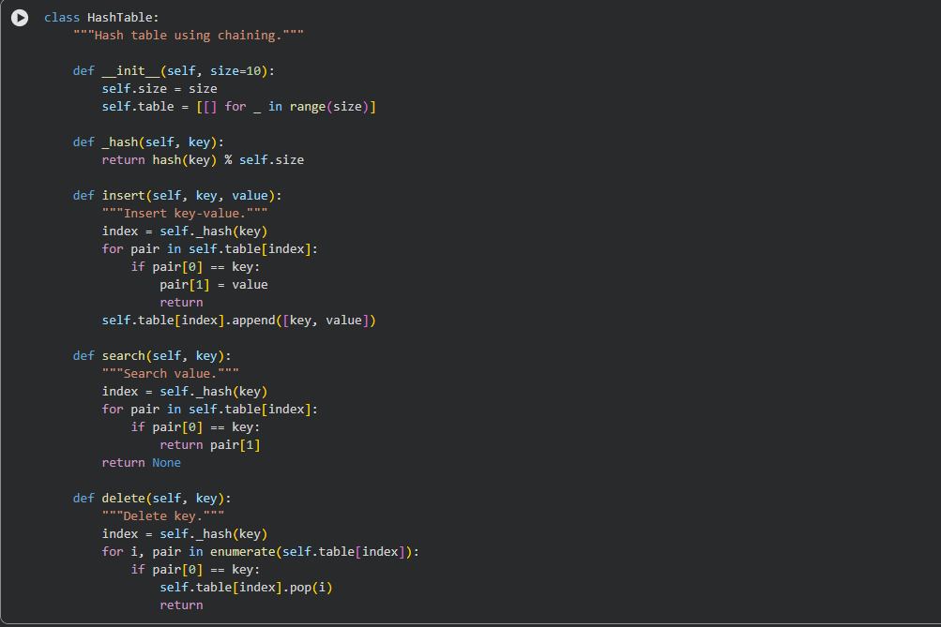
Task 5: University Examination Result Processing


Code Explanation
Large universities process thousands of results, so fast searching is essential. Hashing provides efficient retrieval of student records. Sorting based on marks helps generate rank lists quickly and accurately. Efficient algorithms reduce processing time and improve academic management.
AI Prompt Used
Identify efficient searching and sorting methods for university results and implement Python functions with justification.

Task 6: Online Food Delivery Platform
Recommended Algorithms
Operation | Algorithm | Justification
Search by Order ID | Hashing | Real-time system
Sort by Delivery Time | Merge or Heap Sort | Priority handling
Sort by Price | Quick or Merge Sort | Efficient for large data

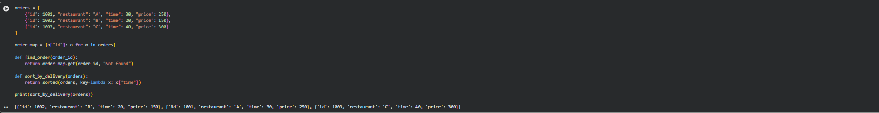
Code Explanation
Food delivery platforms handle real-time data, so quick search and sorting are critical. Hashing enables instant order lookup. Sorting by delivery time improves efficiency and customer satisfaction, while sorting by price supports business analysis. Efficient algorithms ensure scalability and faster performance.
AI Prompt Used
Suggest optimized algorithms for searching and sorting in an online food delivery platform and implement them in Python with justification.

Conclusion
This lab demonstrates how AI can assist in selecting and implementing efficient searching and sorting algorithms. Merge Sort and Binary Search provide strong performance for large datasets, while hashing ensures fast real-time lookup. These techniques improve scalability, performance, and reliability in real-world applications.

